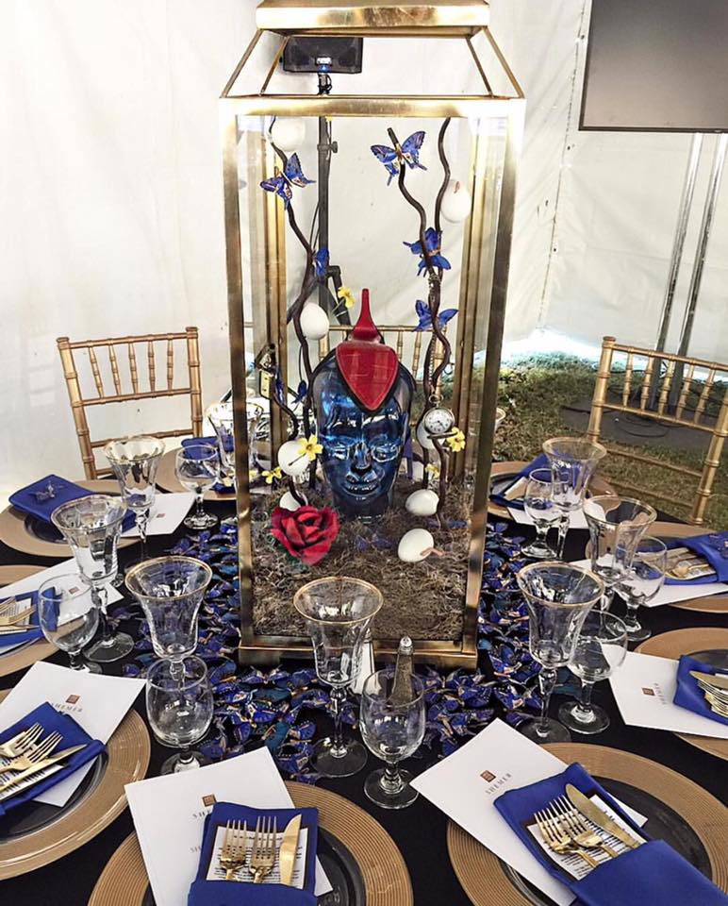

On November 18th the Raegan Ford Interior Design team participated in helping bring awareness to the Shemer Art Center by creating a centerpiece for their event “Shemer Honors.” Shemer Honors is a new art gala created to benefit Shemer Art Center and also celebrate the successful career of artist, Angela Tassoni.

Six interior design firms in the Phoenix area joined forces to support the event and show off their talents. The Designers each drew an artist theme and color to start designing their table and centerpiece. Our artist theme was Salvador Dali, so we decided to put a positive spin on his dark surreal art with our unique centerpiece that consisted of melting watches, eggs, butterflies, and a rose. Known for his use of symbolism from in his dream worlds, these symbols were often repeated throughout his works of art.

Melting Watches: The famous melting watches represent the omnipresence of time, and identify its mastery over human beings. These symbols represent a metaphysical image of time devouring itself and everything else.

The Egg: The egg Is a favorite symbol used by Dali. Given the duality of a hard exterior and soft interior, Dali links the egg to pre-natal images and the intra-uterine universe, and thus it is a symbol of hope and love.

The Butterfly: The Greek work “psyche” meant soul and butterfly. The transformation of the pop into a butterfly and the enormous variety of color and lightness of a butterfly fascinated Dali.

The Rose: To Dali, the rose symbolized as dealing with female sensuality. Red is associated with passion and can also be associated with death and decease. The rose is a symbol of love and passion.

Dali also had an enormous influence in the fashion world. One of his iconic surrealist fashion designs was the shoe hat that was a collaboration between Dali and the Italian Chanel designer Elsa Schiaparelli .

We say hat’s off to the amazingly influential artist Salvador Dali for his individuality, imagination and creative genius!

